## Dear Parent/carer



Read&Write is available for home use. **Free!**

Your school has been using a software tool called Read&Write from Texthelp to help every pupil improve in literacy. We’re pleased to say that this is now available for home use on any device your child uses.

This means that the software they use in school can now also be used at home for homework and study - in an effort by the school to support every child’s learning.

Read&Write is a piece of software that works as a ‘toolbar’ in conjunction with familiar tools such as Word, Google Docs and web browsers. It offers a range of powerful support tools to help students gain confidence with reading, writing, studying and research:

* Text-to-speech to hear words, passages, or whole documents read aloud with easy-to-follow dual color highlighting
* Dictionary definitions and pictures to identify the meaning of words
* With speech-to-text, dictate words to assist with writing, proofreading & studying
* Word prediction to offer suggestions for the current or next word to build writing skills
* Collection of highlights from text in documents, from a web page or PDF for summarising and research to help revision
* Pupils can receive voice notes in their documents to get teacher feedback on work - helping them improve their work faster
* Simplify text on web pages to remove ads and other items that can be distracting

[**Watch this overview video of Read&Write features**](https://www.youtube.com/watch?v=F2oV7WVLHIc&index=4&list=PLvSZbmGbKpCQ9Cw5rDZ66hTxc8eI2ufaj)

## Quick steps to download:

You can download on up to 5 devices - Windows PC, Google Browser, Chromebook and Mac are all supported.

*Click here to download:*[*https://www.texthelp.com/en-gb/products/read-write/read-write-for-education/*](https://www.texthelp.com/en-gb/products/read-write/read-write-for-education/)

Once downloaded and installed, click on the Read&Write icon to run the program – it will ask you to sign in. Pupils must sign in using their Office 365 account details – their school email address and their normal password.

The program will place an extra toolbar above the program in use:

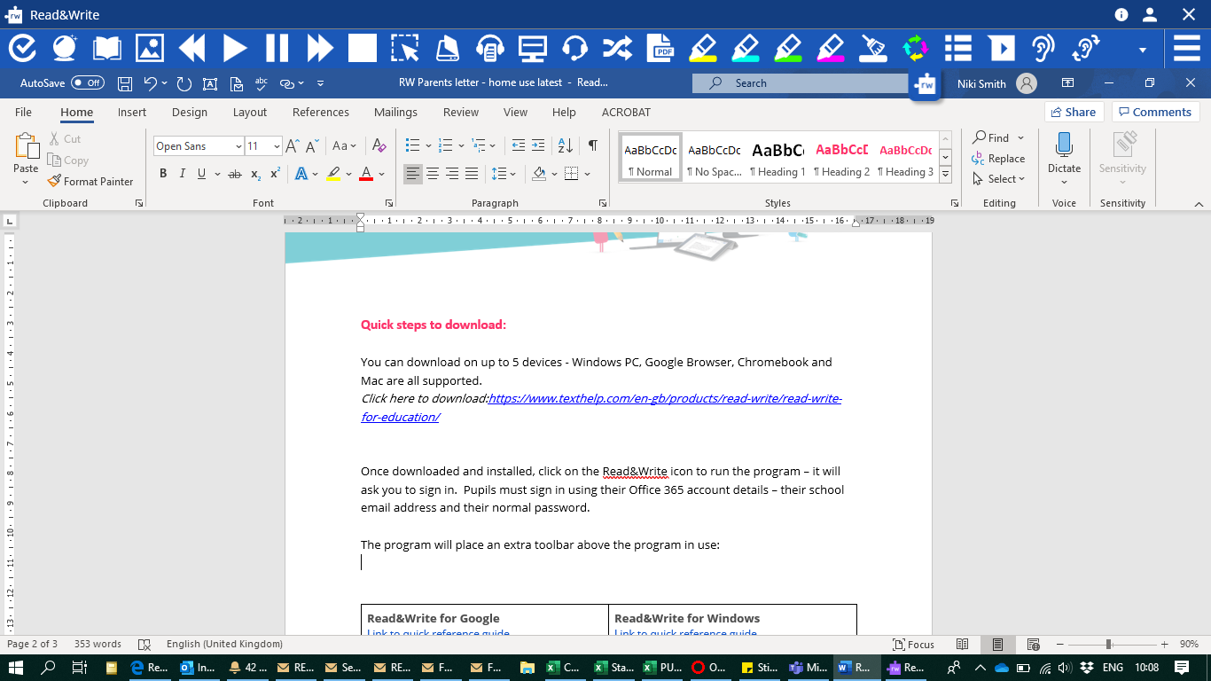

To find out more about what each tool does, please refer to the guides below:

|  |  |
| --- | --- |
| **Read&Write for Google**  [Link to quick reference guide](https://www.texthelp.com/Uploads/MediaLibrary/texthelp/US-Training-Documents/Read-Write-for-Google-Chrome-Quick-Reference-Guide-Oct-2016.pdf)  [Link to training portal](https://training.texthelp.com/course/view.php?id=49)  [Link to YouTube tutorial videos](https://www.youtube.com/playlist?list=PLvSZbmGbKpCTkk3S93CXtQWNf50f_Ow3D&disable_polymer=true) | **Read&Write for Windows**  [Link to quick reference guide](https://www.texthelp.com/Uploads/MediaLibrary/texthelp/US-Training-Documents/Read-Write-for-Windows-quick-ref-card.pdf)  [Link to training portal](https://training.texthelp.com/course/index.php?categoryid=20)  [Link to YouTube tutorial videos](https://www.youtube.com/playlist?list=PLvSZbmGbKpCTBXiXz2me8QF4Gfcsz7LTz) |

